FINAL PRESENTATION SCRIPT

MANTIS
  - Slide-Aligned Script, Demo Master Runbook and Viva Answers
Student: Anuskar Sigdel | 24812606
Presentation rule: 20 minutes including the system demo, followed by a 5-minute viva.
Deck used: MANTIS_Final_Presentation_Key_Points_Demo_Focused.pptx. The PowerPoint is not changed by this document.
Timing target: 9 minutes 55 seconds of non-demo narration, 7 minutes 30 seconds of demo, and 2 minutes 35 seconds of safety buffer.
Demo priority: Section 3 contains the complete command sheet and an exact click-and-say route. Rehearse that section first and keep the non-demo narration concise.
Use the visible slide labels as memory prompts. Do not read the slide. Look at the audience, explain one point, then move on.

1. Timing and Delivery Plan
Delivery principle: Keep the research explanation concise and protect the demo time. If you fall behind, shorten literature and diagrams, not the demo, results or conclusion.
Section | Purpose | Time
Slides 1-15 | Introduction through system design | 7:25
Slides 16-19 | Live demo and architecture explanation | 7:30
Slides 20-25 | Testing, results and conclusion | 2:30
Safety buffer | Transitions, loading delay or examiner interruption | 2:35
Total | Do not exceed | 20:00

Presentation-day essentials
- Arrive at least 15 minutes before the allocated time.
- Wear formal attire and carry the student ID card and admit card.
- Test the laptop, browser, ports 8080 and 9999, terminal commands and backup files before entering.
- Keep active defence disabled for the normal demo. Use it only inside a disposable VM if specifically requested.

2. Slide-by-Slide Speaking Script

Slide 1 | MANTIS | 0:20
Say: Good morning. I am Anuskar Sigdel, and this dissertation presents MANTIS, the Minimalist Alert Network for Threat Intelligence System. MANTIS is a transparent, low-footprint host intrusion detection prototype for commodity Linux. I will briefly explain the research, demonstrate the working system, present the testing evidence and finish with the main findings.

Slide 2 | Introduction: Background and Rationale | 0:25
Say: Small Linux servers, IoT gateways and teaching machines face scans, floods, malicious payloads and known-bad sources, but they may not have the resources for a large enterprise security stack. MANTIS investigates a narrower option: five understandable detection methods in one standard-library system, with every alert retaining the reason for the decision.

Slide 3 | Aim and Objectives | 0:30
Say: The aim was to design, implement and critically evaluate a transparent, low-footprint host NIDS. The objectives were to integrate five engines behind one Verdict contract, support live and PCAP traffic, preserve compatible learned state, produce auditable alerts and SIEM evidence, validate the software separately from wider field accuracy, and compare the prototype honestly with established tools.

Slide 4 | Requirements: Problem and Solutions | 0:30
Say: The problem domain is resource-constrained Linux monitoring. I considered extending Snort or Suricata, using a machine-learning framework, and deploying Wazuh. These are valid systems, but each moves away from this dissertation's first-principles and low-dependency aim. Therefore, I selected a compact Python Standard Library prototype with five complementary transparent methods. This is a scoped engineering decision, not a claim that MANTIS replaces enterprise platforms.

Slide 5 | Functional and Non-Functional Requirements | 0:25
Say: Functionally, MANTIS captures live Ethernet or PCAP traffic, validates protocols, runs five engines, records evidence and can use a policy-gated response path. Non-functionally, it prioritises bounded memory, privacy redaction, reproducible configuration, maintainability and safe failure. Active defence is disabled by default because an alert should not automatically become a firewall change.

Slide 6 | Literature Review | 0:05
Say: The literature review informed both the design choices and the limits of the claims.

Slide 7 | Literature Review: Recent Evidence | 0:35
Say: Halvorsen and colleagues highlighted scarce data, class imbalance, fidelity metrics and the gap between laboratory results and deployment. Neto and colleagues introduced CIC-IoT2023 at large IoT scale. These papers supported external evaluation, but also showed why dataset schema, runtime evidence and deployment assumptions must remain visible. MANTIS therefore does not treat a large dataset or a high headline score as automatic proof of operational accuracy.

Slide 8 | Literature Review: Key Comparisons | 0:35
Say: Hidayat and colleagues compared machine-learning intrusion detectors using multiple metrics and computational cost. This supported a specialised scan-focused KNN engine rather than one universal classifier. Kus and colleagues warned that random splits can inflate accuracy and that withheld attacks can expose generalisation failure. That directly influenced the separation between software tests, matched engine checks and broader field claims.

Slide 9 | Methodology | 0:35
Say: The research follows a constructive method: identify the practical problem, build the artefact, evaluate it and critique the result within its tested boundary. A pragmatic evidence strategy was used because different questions need different evidence. Engine mathematics needs unit tests, the complete pipeline needs integration and replay, and wider accuracy needs appropriate independent data with prevalence and feature compatibility reported.

Slide 10 | Agile, Scrum and Kanban | 0:30
Say: Development used incremental build-and-verify cycles. Scrum ideas such as backlog, review and adaptation were used without pretending that a solo dissertation had a full Scrum team. Kanban limited work in progress to two coding cards and one testing card. Each card linked a module, requirement, test and evidence file, and failed evaluation returned the work to In Progress.

Slide 11 | Algorithm Definitions and Roles | 0:45
Say: The five methods solve different decision problems. Z-Score detects abnormal packet rate. KNN classifies scan behaviour from packet count and unique ports. Naive Bayes classifies privacy-limited payload tokens. K-Means measures novelty as distance from learned centroids. The Bloom Filter tests whether a source belongs to a known-bad set. Their outputs are combined through one Verdict contract rather than forcing every threat into one model.

Slide 12 | Engine Implementation | 0:45
Say: Z-Score uses Welford's online mean and variance and alerts after warm-up when the absolute score exceeds the configured threshold. KNN uses scaled Euclidean distance and a k of three. Naive Bayes stores class and token counts with smoothing. K-Means stores online centroids and withholds anomalous points from centroid updates to reduce contamination. The Bloom Filter uses a fixed bit array and multiple hashes. Compatible state is exported as readable JSON and restored at startup.

Slide 13 | System Analysis: Workflow | 0:45
Say: The workflow begins with validated labelled data for supported training paths and compatible brain-state export. At runtime, AF_PACKET or PCAP provides frames. The parser validates Ethernet, IP and transport fields, and the five engines return Verdict objects. One dispatcher produces logs, UDP SIEM telemetry, dashboard evidence and the forensic report. Optional blocking is policy-gated. Shutdown closes resources and exports state and evidence.

Slide 14 | System Design: Use Cases | 0:30
Say: The main actors are the security administrator, the host operating system and an optional external SIEM. Monitoring, detection and alert generation are mandatory use cases. Investigation, report generation, model management and evidence export support the administrator. Blocking is shown as conditional because it occurs only when active defence is enabled and policy checks pass.

Slide 15 | System Design: Class Model | 0:30
Say: The class model shows SensorNode coordinating capture, parsing and multiple detection engines. The engines inherit a common contract, while AlertDispatcher centralises evidence and can optionally trigger ActiveDefense. Multiplicities show exact ownership: the sensor has one parser, one dispatcher and one or more engines, while active defence remains optional. This design keeps detection separate from response.

3. Demo Master Runbook: Slides 16-19
Demo objective: Show one event moving from host metrics to packet evidence, alert interpretation and architecture. Explain what each value means and what it does not prove.

Slide 16 | Interface Design: Overview | 2:00
Say: This is the operational overview and it refreshes approximately once per second. Host CPU is calculated from the change in total and idle counters in Linux /proc/stat, so it represents whole-host activity, not only the MANTIS process. Host memory uses MemTotal and MemAvailable from /proc/meminfo, so it is also whole-host memory. Sensors Online counts sensor addresses with recent alert telemetry within 60 seconds, which means it may show zero before the first event. Threat Events is the number of alerts retained by the dashboard, and the history is bounded to the newest 100 alerts. I now create or replay a safe event and show how the summary and recent-event row change.
Action: Point to CPU, memory, sensors, threat events and the newest event row. If the dashboard is quiet, move immediately to the prepared replay evidence.
Do not claim: Do not call CPU or memory a MANTIS-only resource measurement. Do not call Threat Events a lifetime count or a count of unique attackers.

Slide 17 | Interface Design: Packets | 2:00
Say: The Packets tab provides traffic context and packet-level evidence. Its ring buffer keeps up to 5,000 recent packet records and automatically discards the oldest when full. Total Seen is cumulative for the session, while Buffered is the current capped collection. PPS is the packet count for the most recent interval, approximately one second. The baseline mean and Z-Score come from the online statistical engine; the score is the distance from normal in standard-deviation units, not an attack probability. Filters, pause and auto-scroll change the display only. Opening a row shows decoded metadata and bounded hexadecimal and ASCII evidence, and the current buffer can be exported as PCAP or JSON.
Action: Filter one protocol or source, open one packet, point to PPS and Z-Score, then mention PCAP and JSON export.
Do not claim: Do not say pause stops capture or detection. Do not describe Z-Score as confidence or probability.

Slide 18 | Interface Design: Alerts | 1:45
Say: The Alerts tab shows security decisions rather than all traffic. I read one alert from left to right: severity, dashboard receive time, sensor identity, detected source, ATT&CK technique, risk and the decision message. Sensor and source are different: the sensor is the host sending telemetry, while source is the address detected in the traffic. Alerts arrive as structured JSON over UDP port 9999. Risk is not probability. It begins with a technique base score, is adjusted using confidence and is clamped from zero to ten. The message is important because it preserves the engine's visible reason for the decision.
Action: Select one alert and explain every displayed field. Connect its message to the responsible engine.
Do not claim: Do not describe risk as the probability that the source is malicious. Do not confuse the telemetry sender with the detected source address.

Slide 19 | Architecture Interface | 1:45
Say: This view connects the interface to the implementation. Live AF_PACKET traffic or PCAP replay enters the parser. The parser creates validated features. Five transparent engines analyse only the evidence relevant to them and return the same Verdict structure. The engines do not directly modify the firewall. AlertDispatcher is the controlled fan-out point for CSV logs, UDP SIEM telemetry, the dashboard, reports and optional response. Blocking is disabled by default and requires blocking to be enabled, the detection kind to be allowed and the source not to be whitelisted. I finish by returning to Overview and showing the same event at summary level.
Action: Trace capture, parser, engines, Verdict, dispatcher, evidence and optional response. Return to Overview to close the loop.
Do not claim: Do not say every alert blocks an address. An alert and a successful firewall rule are separate outcomes.

Safe live-demo setup
Environment: Use only an isolated Linux machine or virtual machine that you own. Keep active defence disabled unless an examiner specifically asks for the optional response test.
Terminal A - start the web dashboard and sensor:
mantis --mode web --ddos-min-pps 500 --ddos-consecutive 3 --alert-dedup-seconds 5
Browser:
http://127.0.0.1:8080
Terminal B - generate safe loopback demonstration traffic:
sudo /usr/bin/mantis-demo-attacks lo 5
Expected live evidence: A port-scan alert with non-zero unique ports, a guarded DDoS alert after sustained traffic, one malicious payload event containing UNION and SELECT, and no duplicate payload alert inside the deduplication window.

Fallback replay if live capture is unreliable
mantis-replay --generate ~/mantis-all-engines.pcap
mantis-replay --pcap ~/mantis-all-engines.pcap --out-json ~/mantis-all-engines-results.json
What to say: This fallback is not a fake screenshot. It replays a standards-conformant 13,159-frame PCAP through the real parser and all five engines without requiring root privileges or external attack traffic.
Expected replay: No alerts during the 0-14 second baseline, followed by KNN scan, guarded Z-Score DDoS, Naive Bayes payload, K-Means novelty and Bloom Filter known-bad detections, with zero malformed packets in the generated capture.

If asked about the report mock-up and the current live counters
Honest answer: The report mock-up visually lists all five engines. The current live stats endpoint exposes dedicated message-based DDoS, SCAN, PAYLOAD and BLACKLIST categories. K-Means anomalies can still appear in the event list, but they are not exposed as a separate live counter. The slide is the report design artefact, while the live implementation should be described exactly as it behaves.

Demo Route: Ten Minutes Focused on the Working System
Recommended route: Use this route when you are allowed to focus more strongly on the system. It protects the most important evidence and gives you a clear recovery path if the live attack or dashboard is delayed.
Time | What to demonstrate
0:00 to 0:40 | State the demo goal and safety boundary
0:40 to 2:10 | Overview: resource cards, events and engine categories
2:10 to 4:10 | Packet capture: counters, one packet, filter and export
4:10 to 5:40 | Threat activity: read one alert from left to right
5:40 to 6:50 | System design: trace the complete detection pipeline
6:50 to 8:20 | Run the safe loopback attack sequence
8:20 to 9:20 | Show the resulting alert and exported evidence
9:20 to 10:00 | Close with limitations and the replay fallback
Opening sentence: I will now demonstrate the real MANTIS pipeline on an isolated Kali Linux virtual machine. I will show live host status, raw packet evidence, classified alerts, the architecture behind those alerts, and independent PCAP and JSON evidence. Active defence is disabled, so this demonstration detects and reports but does not change the firewall.
Safety sentence: The traffic is generated only against loopback on my own virtual machine. No external system is scanned or flooded.

Before the Viva: One-Time Kali Setup
When to run: Run these commands before presentation day while Internet access is available. Do not spend viva time installing packages.
cd ~/Desktop/mantis/src
sudo apt update
sudo apt install -y nmap hping3 curl netcat-openbsd sysstat tcpdump
sudo ./install.sh
What this does: The installer copies the application to /opt/mantis and creates commands including mantis, mantis-replay and mantis-demo-attacks. The extra Kali packages generate safe traffic and provide process and PCAP verification tools.
command -v mantis
command -v mantis-replay
command -v mantis-demo-attacks
mantis --help
sudo /usr/bin/mantis-demo-attacks --help 2>/dev/null || true
What to say: These checks confirm that the installed commands resolve from the shell. I ran them before the viva so the demonstration does not depend on my source directory.

Optional Full Test Check Before Presentation Day
cd ~/Desktop/mantis/src
python3 -m unittest discover -s tests -v
Expected result: The documented final run contains 116 passing tests. Say that this verifies specified software behaviour, not unrestricted field detection accuracy.

Presentation-Day Preflight: Exact Commands
Terminal layout: Open three terminals before the examiner arrives. Terminal A runs MANTIS, Terminal B generates safe loopback traffic, and Terminal C verifies APIs, exports and process usage. Open Firefox at http://127.0.0.1:8080 only after Terminal A reports that the dashboard has started.

1. Confirm that the demo ports are free
sudo ss -ltnp | grep ':8080'
sudo ss -lunp | grep ':9999'
Interpretation: No output normally means the ports are free. Port 8080 is the local HTTP dashboard and port 9999 is the UDP SIEM telemetry receiver.
If a previous MANTIS process is still running: Find it first. Verify the exact process ID before stopping it. Do not blindly terminate unrelated Python processes.
pgrep -af '/opt/mantis/main.py|dashboard_ui/siem.py'
sudo kill <VERIFIED_PID>

2. Start MANTIS in Terminal A
mantis --mode web --ddos-min-pps 500 --ddos-consecutive 3 --alert-dedup-seconds 5
If raw-socket permission fails: Run the same command with sudo. The installer attempts to grant raw-socket capability, but the result depends on the host filesystem and policy.
sudo mantis --mode web --ddos-min-pps 500 --ddos-consecutive 3 --alert-dedup-seconds 5
What the options mean: Web mode starts live capture and the local dashboard. The minimum packet-rate guard is 500 packets per second, the deviation must persist for three consecutive intervals, and identical alerts are suppressed for five seconds.
Baseline wait: Wait at least 30 seconds before generating flood traffic. The Z-Score detector needs warm-up observations to learn a normal packet-rate baseline.

3. Open and verify the dashboard
http://127.0.0.1:8080
curl -s http://127.0.0.1:8080/api/config | python3 -m json.tool
curl -s http://127.0.0.1:8080/api/stats | python3 -m json.tool
What to say: The browser is the operator interface, while these read-only endpoints expose the same live configuration and statistics as structured JSON. This gives me a quick fallback if a visual component is delayed.

4. Keep a replay fallback ready in Terminal C
mantis-replay --generate ~/mantis-all-engines.pcap
mantis-replay --pcap ~/mantis-all-engines.pcap --out-json ~/mantis-all-engines-results.json
Expected evidence: The generated PCAP contains 13,159 frames: 150 baseline, 1,000 scan, 12,000 flood, four payload and five reputation frames. Replay uses the real parser and all five engines, requires no raw-socket privilege, and writes structured JSON. It does not populate the live dashboard.

Screenshot 1: Overview, Exactly What to Point At and Say
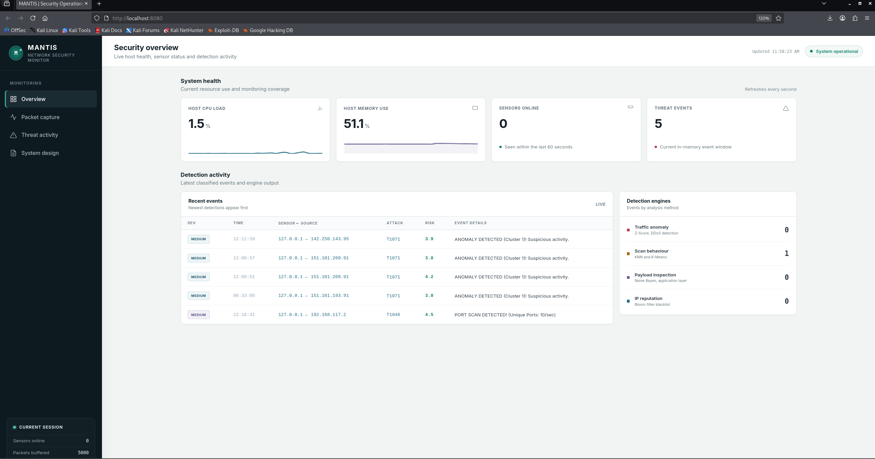
MANTIS Security Overview
Say: This is the operator overview and it refreshes each second. The green System operational badge means the dashboard service is responding. The CPU and memory cards describe the whole Kali host, not only the MANTIS process.
- Point to Host CPU Load. Say: This 1.5 percent value comes from the change in Linux /proc/stat total and idle counters. It is a short-interval whole-host measurement.
- Point to Host Memory Use. Say: This 51.1 percent value is calculated from MemTotal and MemAvailable in /proc/meminfo, so it is also a whole-host figure.
- Point to Sensors Online. Say: Zero does not mean packet capture has failed. The present implementation records a sensor as online after recent alert telemetry, so it can remain zero before a sensor sends an alert.
- Point to Threat Events. Say: Five means five events are currently retained in the in-memory dashboard history. The history is capped at 100 and this is not a lifetime count or a count of unique attackers.
- Point to Recent events. Say: The newest events appear first. The rows show severity, time, sensor and source, ATT&CK context, risk and the human-readable engine decision.
- Point to Detection engines. Say: These are four interface categories. Traffic anomaly represents Z-Score, scan behaviour groups KNN and K-Means, payload inspection represents Naive Bayes, and IP reputation represents Bloom Filter. The implementation still uses five algorithms.

Screenshot 2: Packet Capture, Exactly What to Point At and Say
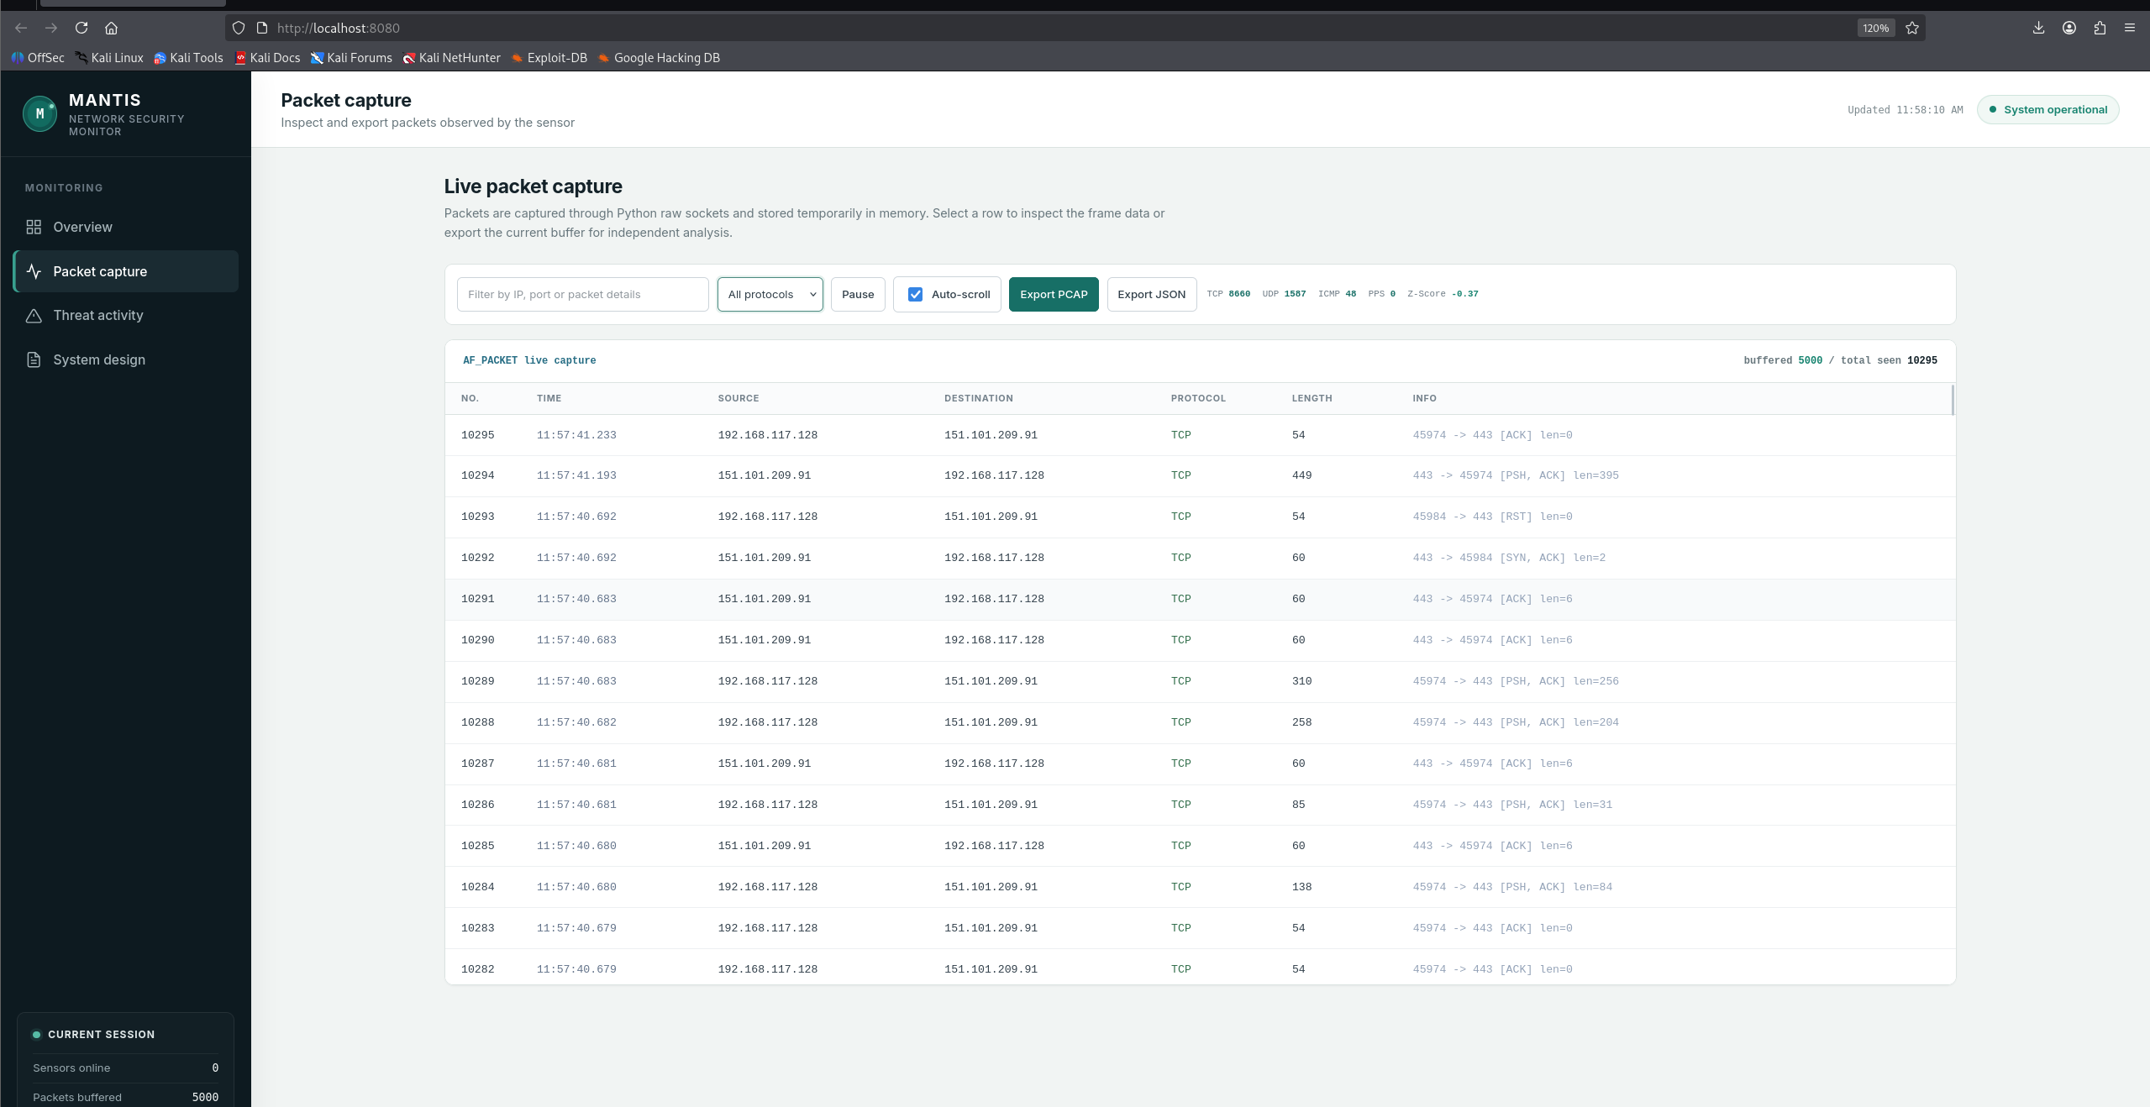
MANTIS Live Packet Capture
Say: This page shows the packet evidence behind detection. Linux AF_PACKET raw sockets capture Layer 2 frames. The parser validates Ethernet, IP and transport fields, and dashboard traffic on ports 8080 and 9999 is excluded to avoid the interface feeding back into its own measurements.
- Point to buffered 5000 and total seen 10295. Say: The ring buffer is full at its safe limit of 5,000 records, but capture continues. New records replace the oldest. Total Seen remains cumulative for this process session.
- Point to TCP 8660, UDP 1587 and ICMP 48. Say: These are cumulative protocol counts for the current session, not current packets per second.
- Point to PPS 0. Say: No in-scope packet was counted in the most recent approximately one-second interval. It does not mean the sensor has never captured traffic.
- Point to Z-Score minus 0.37. Say: This is the signed distance from the learned packet-rate mean in standard-deviation units. A negative value means the current rate is below the mean. It is not a negative attack score and it is not probability.
- Use the search box or protocol menu. Say: Filtering changes only what I see. It does not change capture, analysis or evidence already stored.
- Click Pause. Say: Pause stops browser refresh only. The sensor and detection pipeline continue in the background. Click Resume immediately after explaining it.
- Click one row. Say: The detail contains packet number, time, source and destination, ports, protocol, length, parsed summary, verdict and bounded hexadecimal and ASCII bytes. Payload capture is intentionally limited by the configured snap length. The PCAP and JSON export buttons preserve the current bounded buffer for independent analysis.

Screenshot 3: Threat Activity, Exactly What to Point At and Say
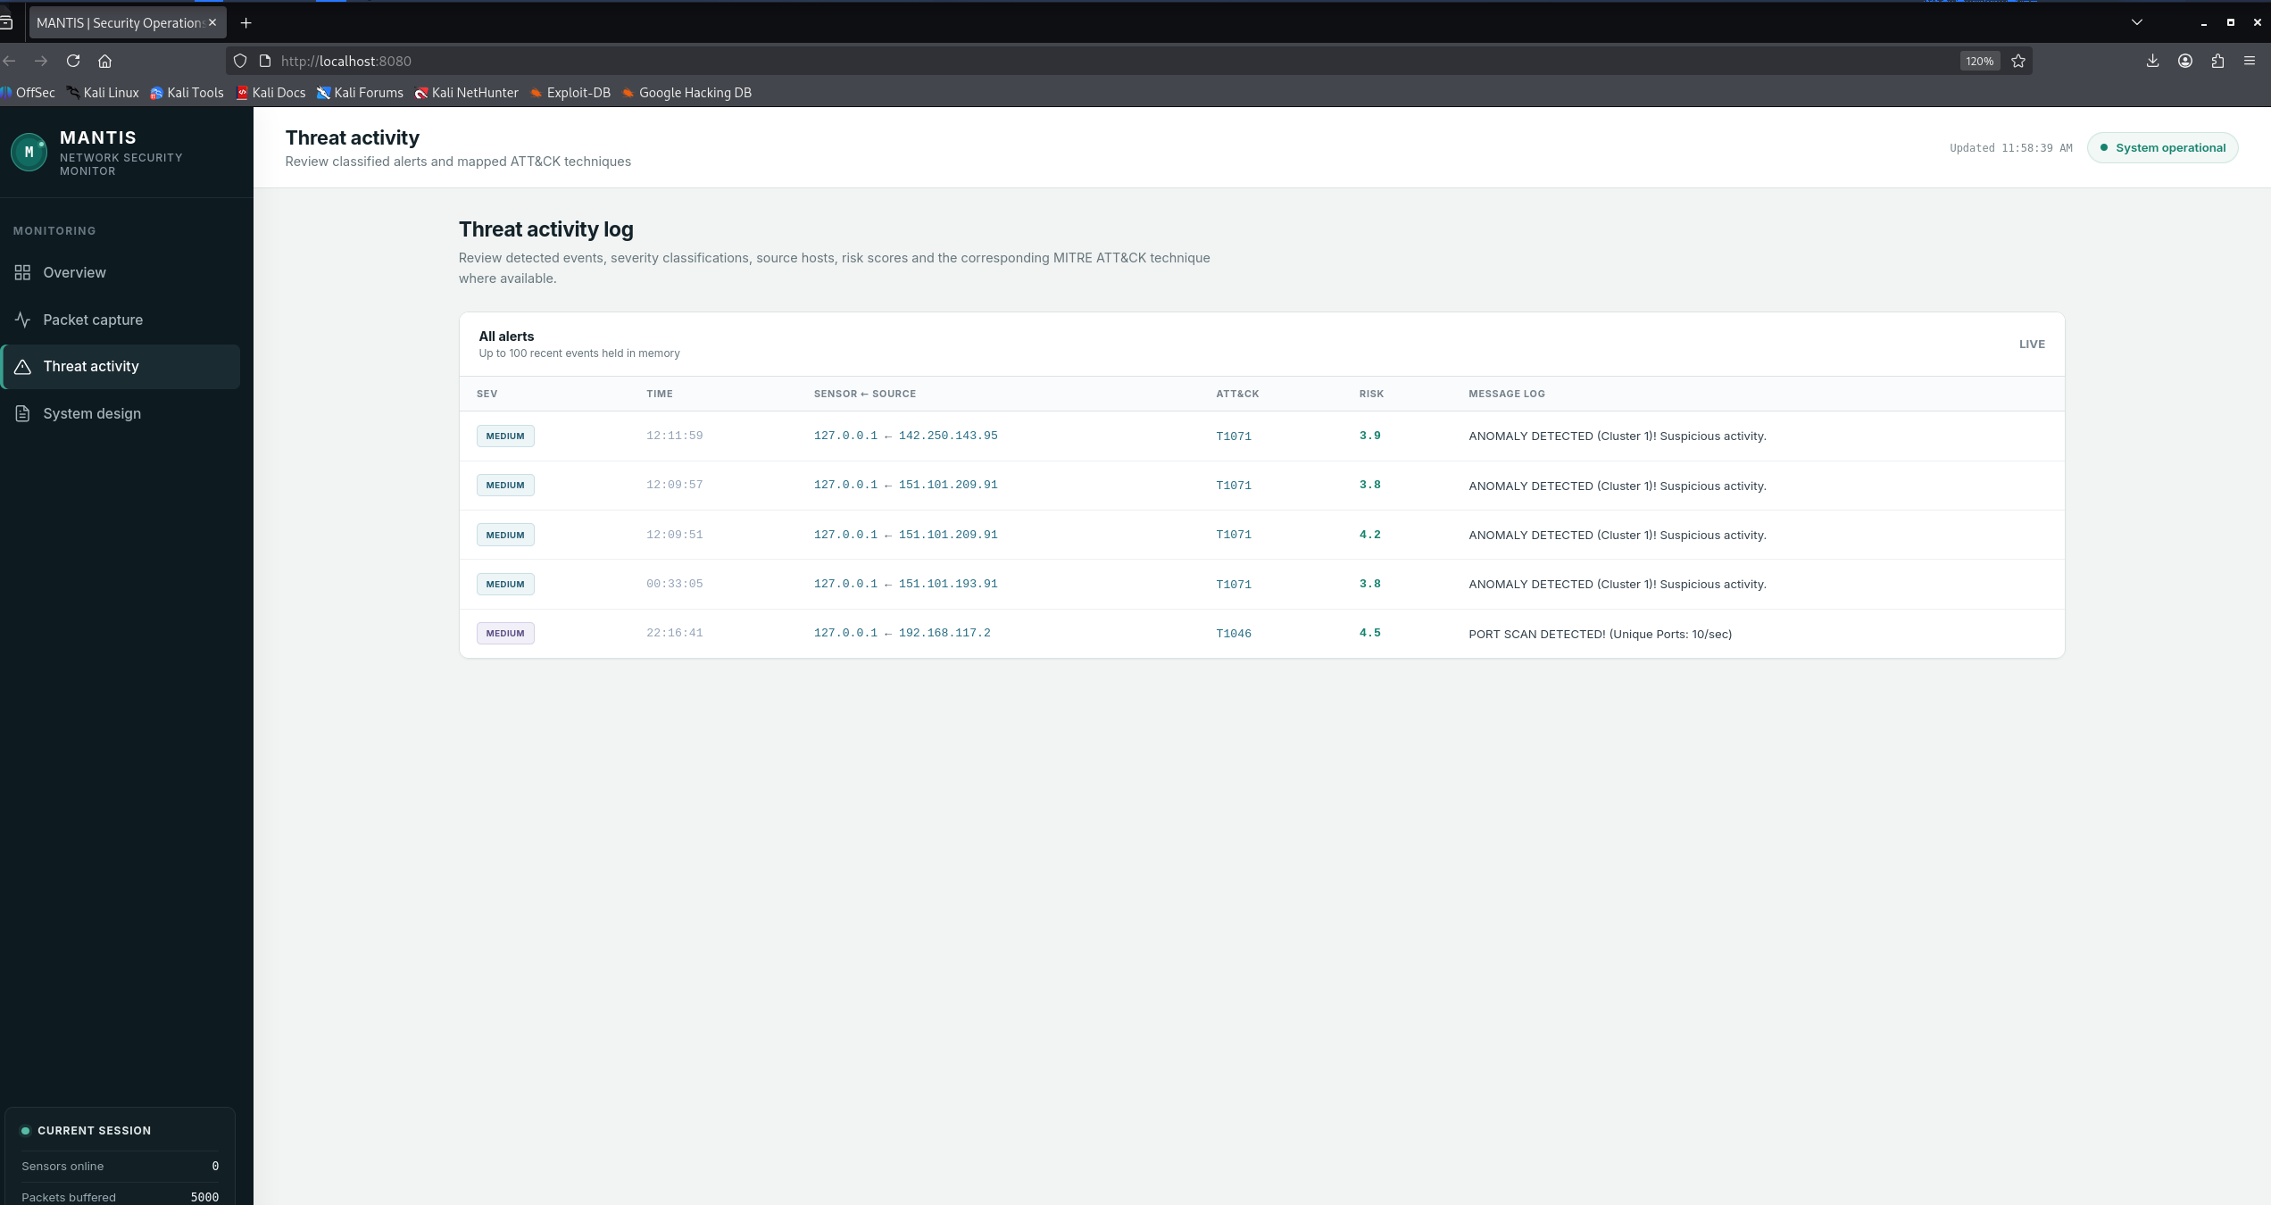
MANTIS Threat Activity Log
Say: This page contains decisions, not every packet. It holds up to the newest 100 in-memory alerts. I will read one row from left to right so the evidence remains understandable.
- Severity is an operational tier for prioritisation.
- Time is when the dashboard received the UDP telemetry.
- The value before the arrow is the sensor address that sent telemetry. The value after the arrow is the source address identified in the event. These are different roles.
- ATT&CK is analyst context. T1071 provides application-protocol context for anomaly rows, while T1046 is network service scanning. A mapping is not proof that an attacker completed the technique.
- Risk is a zero-to-ten prioritisation score. It starts from a technique base value and is adjusted by confidence. It is not the probability that the source is malicious.
- The message is the most important explanation. ANOMALY DETECTED with Cluster 1 is K-Means novelty. PORT SCAN DETECTED with Unique Ports 10 per second is behavioural scan evidence.
Deduplication: The dispatcher uses detection kind, source and message as a key and suppresses an identical alert inside the configured five-second window. This prevents the interface from filling with repeated copies of the same decision.

Screenshot 4: System Design, Exactly What to Point At and Say
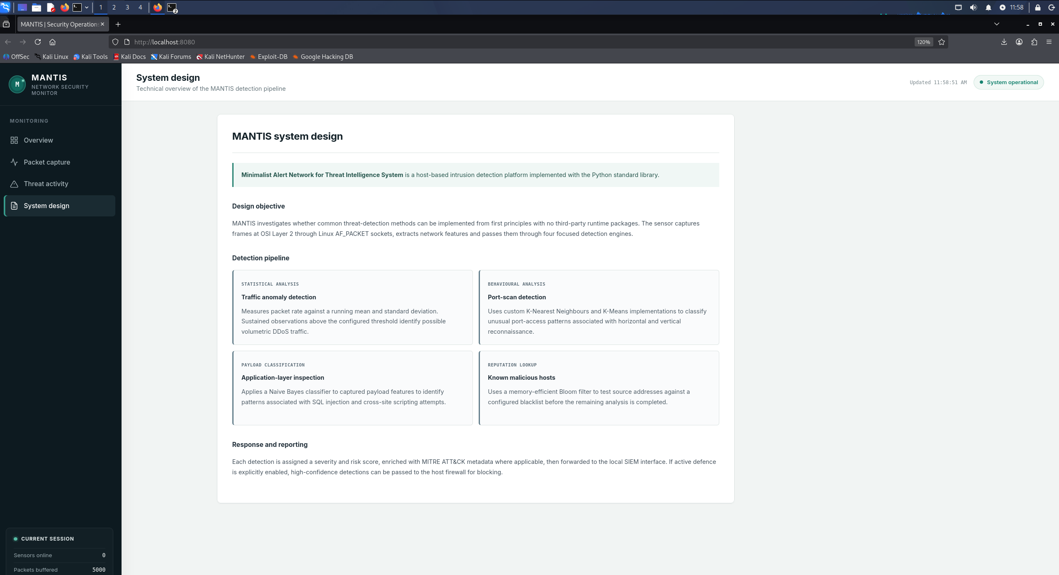
MANTIS System Design View
Say: This page explains how the interface connects to the implementation. MANTIS is host-based and uses Python Standard Library runtime components. Live frames enter through Linux AF_PACKET at Layer 2, or the same parser can process a PCAP during replay.
- Trace Statistical analysis. Z-Score learns packet-rate mean and variance online and raises a guarded alert only after warm-up and sustained threshold breaches.
- Trace Behavioural analysis. KNN classifies packet-count and unique-port scan patterns. K-Means independently measures novelty as distance from learned centroids. This single interface card therefore represents two algorithms.
- Trace Payload classification. Naive Bayes classifies privacy-limited payload tokens for patterns such as SQL injection and cross-site scripting.
- Trace Reputation lookup. The Bloom Filter performs memory-efficient membership checks against configured known-bad sources. A hit is marked as reputation evidence because Bloom Filters can have false positives.
- Finish with response and reporting. All engines return a common Verdict. AlertDispatcher then sends evidence to CSV logging, UDP SIEM telemetry, the dashboard and reports. Optional firewall response is separate and disabled by default.

Run the Live Attack Sequence and Narrate It

Terminal B command
sudo /usr/bin/mantis-demo-attacks lo 5
Say before pressing Enter: This packaged demonstration sends traffic only to 127.0.0.1 on my own VM. It runs a SYN scan, a short controlled SYN flood and a local HTTP request containing SQL-injection tokens. MANTIS was started first and was allowed to learn a baseline.

Attack 1: Port scan
nmap -sS -p 1-200 127.0.0.1
What happens: The traffic touches many destination ports over a short interval. The scan feature vector includes packet count and unique ports. KNN compares the scaled vector with learned neighbours, while K-Means can also identify unusual behaviour by centroid distance.
Expected live evidence: A port-scan message should appear with non-zero unique ports and ATT&CK T1046. Exact timing and count can vary with the VM.

Attack 2: Short guarded SYN flood
timeout 5 hping3 -S --flood -p 80 127.0.0.1
What happens: The packet rate rises sharply. Z-Score compares each approximately one-second PPS value with the learned mean and variance. The minimum-PPS guard and three-consecutive-interval rule reduce alerts from a single brief spike.
Expected live evidence: The PPS and Z-Score should rise and a DDoS-style traffic-anomaly alert may appear after the sustained guard is satisfied. If the VM scheduling prevents the alert, show the replay result and explain the guard rather than repeatedly flooding.

Attack 3: Local payload request
http://127.0.0.1:8085/?id=1%20UNION%20SELECT%20user,password%20FROM%20users
What happens: The helper temporarily starts a local netcat listener and sends an HTTP request containing UNION and SELECT tokens. Naive Bayes tokenises only the bounded visible payload and compares malicious and benign class scores.
Expected live evidence: One payload alert should appear. An identical message inside the five-second deduplication window should not produce an immediate duplicate.

Optional Bloom Filter reputation demonstration
sudo hping3 -I lo -c 1 -a 10.0.0.66 -S -p 80 127.0.0.1
Say: This sends one loopback packet with a configured test source. With active defence disabled, a Bloom membership hit should be reported as Flagged, not Blocked. A Bloom hit is probabilistic set-membership evidence and can be a false positive.
Safety rule: Do not enable blocking for the normal viva. If an examiner asks about it, explain the policy checks instead of modifying the firewall.

Show Independent Evidence After the Alerts

Export the live packet buffer
curl -o ~/mantis_capture.pcap http://127.0.0.1:8080/api/export.pcap
tcpdump -nn -r ~/mantis_capture.pcap -c 5
curl -o ~/mantis_capture.json http://127.0.0.1:8080/api/export
python3 -m json.tool ~/mantis_capture.json | head -40
Say: The PCAP is not a screenshot. It is a standard libpcap file created from the bounded in-memory packet ring and can be independently decoded by tcpdump or Wireshark. The JSON export exposes the same recent records in a structured format.

Show alert logging
tail -n 10 mantis_logs.csv
Say: The dashboard is not the only evidence path. AlertDispatcher also writes structured CSV evidence. If this relative file is absent, I first check the working directory used to launch MANTIS rather than claiming that logging failed.

Measure the MANTIS process, not the whole host
uname -a
python3 --version
lscpu
free -h
PID=$(pgrep -f '/opt/mantis/main.py' | head -n 1)
pidstat -p "$PID" 1 5
ps -o pid,%cpu,rss,etime,cmd -p "$PID"
Say: The dashboard CPU and memory cards are whole-host metrics. These commands record the environment and measure the MANTIS process separately. RSS is reported in KiB and can be divided by 1,024 for MiB.

Stop safely and verify what exists
# In Terminal A, press Ctrl+C
ls -lh mantis_logs.csv ~/mantis_capture.pcap ~/mantis_capture.json ~/mantis-all-engines.pcap ~/mantis-all-engines-results.json 2>/dev/null
Honest wording: I stop the process with Ctrl+C and verify the files that were actually created. I do not promise that every shutdown artefact is written unless it is visible, because the current daemon-thread lifecycle can make orderly sensor shutdown dependent on how the process exits.

Fast Troubleshooting and Recovery Commands

Dashboard does not open
curl -v http://127.0.0.1:8080/api/stats
sudo ss -ltnp | grep ':8080'
pgrep -af '/opt/mantis/main.py|dashboard_ui/siem.py'
Recovery: Check Terminal A for an error. If the API works but charts do not load, the page's Chart.js CDN resource may be unavailable. Keep the dashboard page loaded before the viva and use the JSON endpoint and replay output as evidence rather than editing the system during the examination.

Raw socket permission denied
sudo mantis --mode web --ddos-min-pps 500 --ddos-consecutive 3 --alert-dedup-seconds 5
Explanation: AF_PACKET capture requires raw-socket permission. Using sudo inside the isolated VM is the presentation fallback.

Installer or script shows carriage-return errors
cd ~/Desktop/mantis/src
sed -i 's/\r$//' *.py install.sh
Explanation: This removes Windows CRLF carriage returns from copied source scripts before installation.

No live alert appears
- Confirm MANTIS started before the helper and that the 30-second baseline wait completed.
- Return to Packet capture and confirm Total Seen is increasing.
- Check Terminal A for parser or permission errors.
- Do not keep repeating the flood. Switch to the prepared PCAP replay and explain that replay uses the same parser and engines but does not populate the live dashboard.
mantis-replay --pcap ~/mantis-all-engines.pcap --out-json ~/mantis-all-engines-results.json

Port 8080 is already used
sudo ss -ltnp | grep ':8080'
pgrep -af '/opt/mantis/main.py|dashboard_ui/siem.py'
sudo kill <VERIFIED_PID>
Safety: Stop only a process you have verified as the stale MANTIS instance. Never kill an unknown service just to free the port.

Last-resort sixty-second demo
Say: This overview shows whole-host resource status and the newest bounded alert history. The packet page proves AF_PACKET capture and provides PCAP and JSON export. The alert page preserves severity, sensor, source, ATT&CK context, risk and the engine decision. The design page traces raw frames through the parser, five algorithms, one Verdict and controlled evidence outputs. If live traffic is delayed, this prepared PCAP is replayed through the real parser and all five engines.

Claims to Avoid During the Demo
- Do not say host CPU or memory is MANTIS-only usage.
- Do not say Sensors Online zero means capture is stopped.
- Do not say Pause stops the sensor or detection.
- Do not call Z-Score, risk or Bloom membership an attack probability.
- Do not call Threat Events a lifetime total or unique-attacker count.
- Do not claim four algorithms because the interface has four categories. The implementation has five algorithms.
- Do not claim replay populates the live dashboard.
- Do not say every alert blocks an address. Active defence is disabled by default and policy-gated.
- Do not claim 116 tests prove real-world detection accuracy.
- Do not promise an alert or exact count before it is visible. Use the expected range and the replay fallback.

4. Testing, Results and Conclusion Script

Slide 20 | Testing 1: Strategy and Unit Tests | 0:20
Say: Testing covered unit, integration, system, regression and training behaviour. The final documented run passed 116 tests in 4.642 seconds. Generated frames and PCAP data made mathematics, parsing, privacy, persistence and safe-failure checks repeatable.

Slide 21 | Testing 2: Integration Checks | 0:20
Say: Integration tests follow parser to engines, Verdict, dispatcher and outputs. White-box checks inspect scaling, deduplication, redaction and policy branches. Black-box checks exercise the CLI, UDP 9999, HTTP 8080, malformed datagrams and valid exports without changing the real firewall.

Slide 22 | Testing 3: Algorithm-Specific Checks | 0:30
Say: Each engine needs its own test style: Z-Score warm-up and sustained floods; KNN scaling and scan separation; K-Means novelty and withheld anomaly updates; Naive Bayes benign and malicious tokens; and Bloom loading, saturation and inserted-indicator behaviour.

Slide 23 | Results: Algorithm Accuracy | 0:30
Say: On small domain-matched checks, KNN, Z-Score, K-Means and Bloom were perfect; Naive Bayes recall was 0.9167 and F1 was 0.9565. These results verify intended code paths, but different tasks and datasets make the engines non-comparable and do not prove field accuracy.

Slide 24 | Results: Dataset Findings | 0:30
Say: The evidence categories remain separate: 116 tests verify software behaviour, 173 matched samples verify engine logic, and the 13,159-frame PCAP verifies replay. The 299,994-row review had 0.9761 attack prevalence, so an always-positive classifier could reach F1 0.9879. Headline F1 can therefore mislead.

Slide 25 | Conclusion | 0:20
Say: MANTIS contributes five transparent engines in one inspectable workflow, with bounded storage, privacy controls and policy-gated response. The evidence supports a working research prototype within the stated laboratory scope, not an enterprise replacement or unrestricted accuracy claim. Future work should use independent balanced evaluation, authenticated telemetry and wider IPv6 support. Thank you, and I am ready for questions.

5. Detailed Demo Reference

CPU load
Definition: Whole-host Linux CPU utilisation for the most recent refresh interval.
Implementation: The dashboard reads the first CPU line from /proc/stat. It calculates deltas between total and idle counters and returns 100 multiplied by busy delta divided by total delta.
Meaning: A short spike means the host was busy during that interval. It does not identify which process caused the load.
Process-level evidence: Use ps -o pid,%cpu,rss,etime,cmd -p <PID> or pidstat -p <PID> 1 5. Divide RSS in KiB by 1024 for MiB.

Memory
Definition: Whole-host memory utilisation.
Implementation: The dashboard reads MemTotal and MemAvailable from /proc/meminfo and calculates 100 multiplied by (MemTotal minus MemAvailable) divided by MemTotal.
Meaning: The value shows how much host memory is unavailable, not the sensor process's resident memory.

Sensors Online
Implementation: A sensor address is online when its most recent alert telemetry arrived less than 60 seconds ago.
Important limitation: The last-seen map is alert-telemetry based. Before the first alert, the number can be zero even while capture is running.

Threat Events and engine counters
Threat Events: The current number of retained dashboard alerts. ALERT_HISTORY is a deque capped at 100, so this is not a lifetime total.
Engine counters: The current stats endpoint counts retained alert messages in DDoS, SCAN, PAYLOAD and BLACKLIST categories. K-Means alerts remain visible in the event list even though there is no separate live counter.

PPS, baseline and Z-Score
PPS: Packet count accumulated during the most recent interval of approximately one second.
Baseline: The online learned mean packet rate used by the Z-Score engine after warm-up.
Z-Score: The signed distance between current PPS and the learned mean in standard-deviation units. The alert rule uses the configured absolute threshold and guard conditions.

Packet storage and export
Buffered: Current packet records in the deque, capped at 5,000 by default.
Total Seen: Cumulative packets observed during the current process session.
Exports: JSON provides structured recent evidence. PCAP creates a standards-conformant capture suitable for Wireshark or tcpdump.

Alert fields
Severity: An operational tier derived from the detection and ATT&CK context.
Time: The time the dashboard received the UDP alert.
Sensor: The host address that sent the telemetry.
Source: The address identified in the detected packet or event.
ATT&CK: The mapped tactic and technique used to provide analyst context.
Risk: A zero-to-ten operational score based on a technique base score and confidence. It is not probability.
Message: The human-readable decision evidence from the responsible engine.

Active defence
Default: Disabled.
Block conditions: Blocking must be enabled, the detection kind must be allowed by policy, the source must not be whitelisted, and the firewall action must succeed.
Safe viva wording: The system can request a policy-gated iptables action. An alert is not the same as a successful block.

6. Viva Questions and Model Answers

Prepared viva questions

1. What is MANTIS?
Model answer: MANTIS is a transparent, low-footprint host intrusion detection prototype for commodity Linux. It combines raw capture, five inspectable detection engines, one Verdict contract, structured evidence, a web SIEM, brain-state persistence and optional policy-gated response using the Python Standard Library.

2. What is the main research contribution?
Model answer: The contribution is not a claim of a new universal classifier. It is the integration of five transparent methods into one auditable end-to-end workflow, together with reproducible tests, replay evidence and an honest critique of dataset assumptions and metric interpretation.

3. Why use five algorithms?
Model answer: The threats expose different features. Floods are rate anomalies, scans are port and packet patterns, payload attacks are token patterns, behavioural novelty is centroid distance, and reputation is set membership. One model would hide these different assumptions and evidence types.

4. Why avoid third-party runtime packages?
Model answer: The constraint supports portability, auditability and a smaller dependency surface on commodity Linux. It also forces the mathematics and packet parsing to remain inspectable. The trade-off is less protocol breadth and fewer optimised numerical routines than mature tools or machine-learning frameworks.

5. How does the Z-Score engine work?
Model answer: It maintains online mean and variance using Welford's method. After warm-up, current PPS is compared with the learned mean and standard deviation. A guarded sustained deviation above the configured threshold produces a Verdict. Predicting before updating and guard conditions reduce baseline poisoning.

6. Why Welford's method?
Model answer: Welford's method updates mean and variance in one pass without retaining every historical sample. It is numerically stable and suitable for bounded-memory streaming detection.

7. How is KNN implemented?
Model answer: KNN uses packet count and unique-port features, scales them before distance calculation, and applies a k of three nearest-neighbour vote. Scaling matters because otherwise a large-range feature can dominate Euclidean distance.

8. Why is k equal to three?
Model answer: A small odd k supports a simple local majority and avoids a two-neighbour tie. It was selected and tested for the dissertation's small scan feature space. It is a configuration choice, not a universally optimal value.

9. How is Naive Bayes used?
Model answer: The engine tokenises the privacy-limited visible payload, stores class and token counts, applies smoothed likelihoods and compares malicious and benign class scores. It is transparent because the token evidence and class statistics remain inspectable.

10. How does K-Means detect novelty?
Model answer: The engine learns centroids for familiar numerical behaviour and measures the distance of a new feature vector from the nearest centroid. A sufficiently distant point is treated as novelty. Anomalous points are withheld from centroid updates so they do not immediately redefine normal behaviour.

11. What are the Bloom Filter's limitations?
Model answer: A Bloom Filter can return false positives because multiple items share bits, but an inserted item should not produce a false negative. Therefore a membership hit is reputation evidence, not final proof of malicious intent.

12. What is the common Verdict contract?
Model answer: Each engine returns a consistent decision object containing the engine identity, label, confidence and human-readable evidence. This allows the dispatcher, logger, dashboard and response policy to handle different algorithms consistently without hiding their specific reasoning.

13. Does the CPU card show MANTIS CPU usage?
Model answer: No. It shows whole-host CPU utilisation derived from /proc/stat counter deltas. MANTIS process CPU must be measured separately using pidstat or ps for the sensor PID.

14. Does the memory card show MANTIS RAM?
Model answer: No. It shows whole-host memory from MemTotal and MemAvailable in /proc/meminfo. Process RSS from ps is the appropriate MANTIS-specific measurement.

15. Why can Sensors Online be zero while the sensor is running?
Model answer: The current last-seen map is updated by alert telemetry. A sensor can be capturing traffic but remain absent from that map until it sends an alert. This is an implementation limitation that future authenticated heartbeat telemetry could address.

16. What does the risk score mean?
Model answer: It is an operational prioritisation score from zero to ten based on a technique base score and confidence adjustment. It is not a calibrated probability that the event is malicious.

17. Why use bounded buffers?
Model answer: Bounded buffers prevent uncontrolled memory growth. The dashboard retains the newest 100 alerts and the packet store retains 5,000 packet records by default, dropping the oldest when full. The trade-off is that the dashboard is not a permanent evidence database.

18. What is the difference between unit, integration and system testing?
Model answer: Unit tests isolate mathematics and individual functions. Integration tests verify contracts such as parser to engine to dispatcher. System tests exercise externally visible behaviour such as CLI commands, HTTP 8080, UDP 9999 and valid PCAP export.

19. What is white-box versus black-box testing here?
Model answer: White-box testing inspects internal branches such as scaling, deduplication, redaction and response policy. Black-box testing supplies inputs through public interfaces and checks outputs without depending on internal implementation details.

20. Do 116 passing tests prove high detection accuracy?
Model answer: No. They prove specified software behaviour across the documented cases. Detection accuracy requires representative labelled evaluation data, independent splits, appropriate metrics and analysis of assumptions. Software correctness and field accuracy are separate claims.

21. Why are several matched-engine scores equal to one?
Model answer: Those small sets were deliberately matched to each engine's domain and verify that the intended code path works. Their perfect scores are not evidence of unrestricted deployment performance, and the engines cannot be compared directly because their tasks and sample sets differ.

22. What is important about the 299,994-row dataset result?
Model answer: The external review had attack prevalence 0.9761. An always-positive classifier could achieve F1 0.9879, showing that headline F1 can look excellent even without useful discrimination. Prevalence, specificity, MCC and feature compatibility must therefore be considered.

23. Was MANTIS trained on all 299,994 external rows?
Model answer: Do not claim that. The 299,994 rows are an external evaluation and re-appraisal category, not proof that every engine trained on that many records. The currently inspected saved brain retains 32,173 KNN exemplars with k equal to three. Training state, raw corpus rows and evaluation rows must be reported separately.

24. Why use replay instead of only live attacks?
Model answer: Replay is reproducible, safe and unprivileged. The 13,159-frame generated PCAP passes through the real parser and all five engines and can be independently opened in Wireshark. Live attacks show operational behaviour but do not provide identical input across repeated runs.

25. Why is active defence disabled by default?
Model answer: A false positive that automatically changes the firewall can interrupt legitimate access. MANTIS therefore requires explicit enablement, an allowed detection category, whitelist checks and a successful iptables action. This keeps response proportional and reversible.

26. What are the main limitations?
Model answer: The evidence is laboratory-bounded, payload analysis is limited to visible plaintext, telemetry is unauthenticated UDP, AF_PACKET is Linux-specific, the dashboard uses bounded in-memory history, and the external dataset does not perfectly match every engine's native feature schema.

27. What would you improve next?
Model answer: I would add authenticated and encrypted telemetry, independent balanced evaluation with strict train-test separation, calibrated thresholds, IPv6 and richer protocol support, explicit sensor heartbeat status, longer-term evidence storage and usability evaluation with real operators.

7. Emergency Short Versions

If only 60 seconds remain
Say: MANTIS is a transparent, standard-library Linux host intrusion detection prototype combining Z-Score, KNN, Naive Bayes, K-Means and Bloom Filter engines behind one Verdict and evidence pipeline. The system was verified through 116 automated tests, small engine-specific checks and a reproducible 13,159-frame replay. The results support a working laboratory prototype, not unrestricted field accuracy. Its main contribution is inspectable detection with bounded storage, privacy controls and policy-gated response.

If the live demo fails
Say: The live environment is not producing reliable traffic, so I will use the prepared PCAP fallback. This capture is standards-conformant and passes through the same parser and engines as live capture, which preserves the end-to-end demonstration without generating external attack traffic.
mantis-replay --pcap ~/mantis-all-engines.pcap --out-json ~/mantis-all-engines-results.json

If interrupted during a detailed explanation
Bridge sentence: The key point is that the value is transparent, bounded and linked to a specific code path. I will move to the live evidence and return to the calculation during the viva if required.

Final checklist
- PowerPoint and DOCX available locally and on a backup drive.
- Prepared PCAP and JSON results available offline.
- Browser pre-opened at 127.0.0.1:8080.
- Terminal commands tested without relying on Internet access.
- Active defence disabled unless explicitly requested in an isolated VM.
- Student ID card and admit card ready; formal attire; arrive 15 minutes early.

Sources used for this script
- MANTIS_Final_Presentation_Key_Points_Demo_Focused.pptx, slides 1-25.
- MANTIS_Final_Dissertation_FINAL_BACKUP_CURRENT_SAVED_STATE_2026-08-22_160017.docx.
- TEST_GUIDE.md, safe regression, replay, dashboard and performance procedures.
- src/dashboard_ui/siem.py, src/utils/packet_store.py, src/sensor_node/sensor.py, src/utils/mitre.py and the dispatcher, logger and active-defence modules.
- src/data/mantis_brain_20260725_213912.json, inspected saved KNN state.

